Project Initialization and Planning Phase

Date | June 2024
Team ID | 740053
Project Name | Estimating the stock keeping units using Machine Learning
Maximum Marks | 3 Marks

Define Problem Statements(Customer Problem Statement Template):

Create a problem statement to understand your customer's point of view. The Customer Problem Statement template helps you focus on what matters to create experiences people will love. A well-articulated customer problem statement allows you and your team to find the ideal solution for your customers' challenges. Throughout the process, you’ll also be able to empathize with your customers, which helps you better understand how they perceive your product or service.
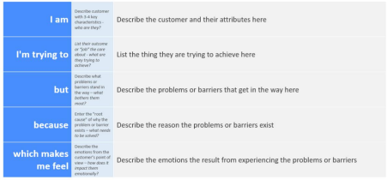
Reference: https://miro.com/app/board/uXjVK2aqlmY=/?share_link_id=534024970903
Example:
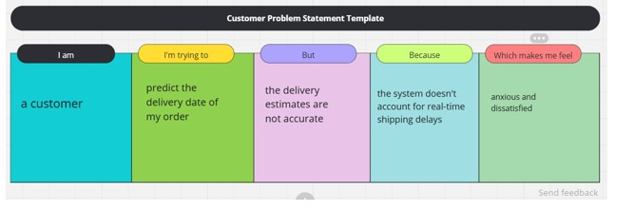

Problem  Statement (PS) | I am | I’m trying to | But | Because | Which makes me feel
PS-1 | customer | Predict the stock units of my stock | The stock estimate are not accurate | The system doesn't account for real-time SKUs delays | Anxious and dissatisfied
PS-2 | a stakeholder | make sure SKUs predicted successfully | the SKUs estimates are unavailable | the system doesn’t account for holidays or peak times | worried and disappointed

